109550198 卜銳凱

Introduction to Database System

HW3

Report

**2-A. Questions Answering**

1. Describe the general (high-level) structure of SQLite code base

a.show a diagram of SQLite structure

As indicated in the SQLite documentation regarding SQLite structure, this diagram depicts the main components of SQLite and how they interoperate.

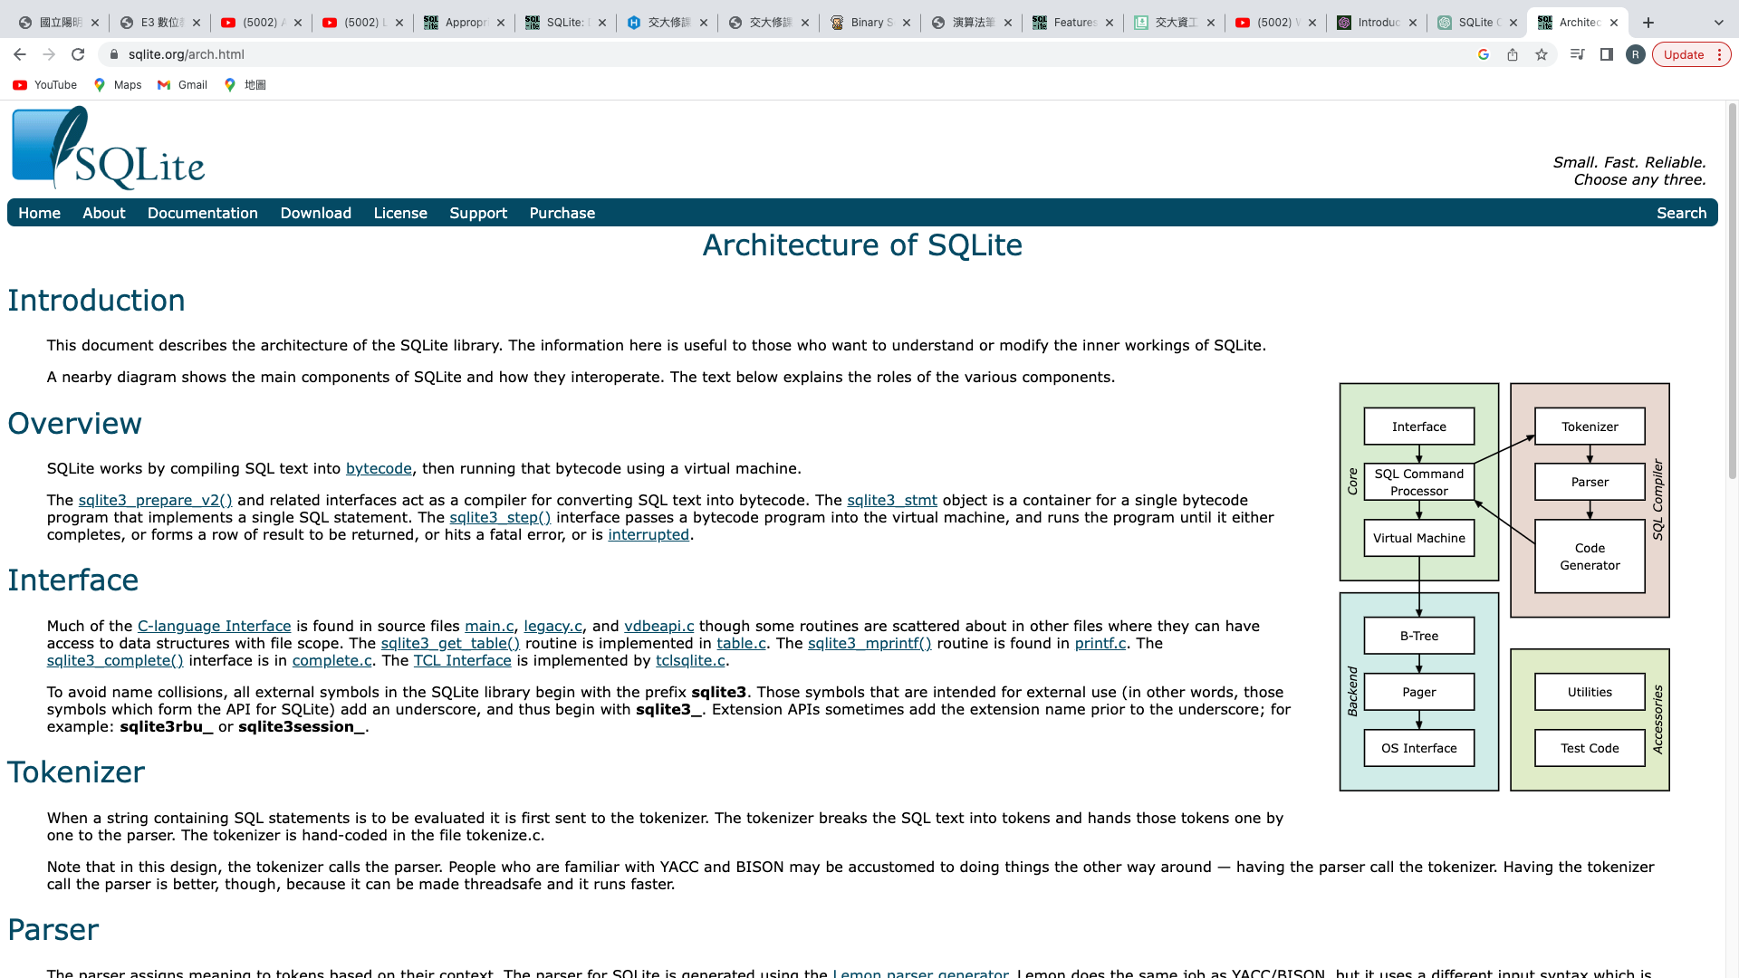

**b. list the components of SQLite and describe their functionality.**

As indicated in SQLite documentation, The block diagram above depicts the SQLite database components and their relationships. Let us grab an idea of each component from the below segment.

**Interface:**SQLite’s library is implemented with the functions main.c, legacy.c, and vdbeapi.c. Sqlite library starts with Sqlite3 to avoid collisions with other applications**.**

**Tokenizer:**Tokenizer breaks down strings and separates tokens before passing them to the parser.

**Parser:**The Lemon LALR (1) parser generator is used to generate the parser. Parse assigns the token meaning.

**Code generator:**The code generator generates virtual machine codes for SQL statements, allowing the user's request to be satisfied. The generator contains several files that aid in the generation of code, such as build.c, delete.c, attach.c, expr.c, insert.c, pragma.c, select.c, auth.c, and so on.

**Virtual machine:**The virtual machine under SQLite database structure runs the code generated by the code generator. It has its own header file called; vdbe.h and the entire machine is stored in single vdbe.c file**.**

**B-tree:**The database has a B-tree structure, and distinct B-trees are used for indexes and tables. All these trees are stored under a single disk.

**Page cache:**The information is seen in fixed chunks, and the B-trees module requests this data or information. The page cache aids with the reading, writing, and so on of the chunks.

**OS Interface**:SQLite employs the abstraction layer, which is specified in os.h, to interface with the operating system. Depending on the operating system, the implementation may vary.

**Utilities:**Memory allocation, caseless string comparison routines, portable text-to-number conversion routines, and other utilities are all included in util.c. The symbol tables utilized by the parser are maintained by hash tables found in hash.c. Unicode conversion subroutines can be found in the utf.c source file. SQLite features its own private version of printf() (with some extensions) in printf.c, as well as its own pseudo-random number generator (PRNG) in random.c.

**Test code:**

The "src/" folder in the source tree contains files with names that start with test that are exclusively intended for testing and are not included in a standard build of the library.

**c. recall the lecture of Database System Concepts, compare components of SQLite to the components mentioned in the lecture slides, what are the special features of SQLite**

As indicated in the lecture of Database System Concepts and SQLite documentation, many of the components listed in the lecture of Database System Concepts match the components of SQLite. Here is a mapping of the components.

Program Object Code: The SQLite library, which contains the compiled code for SQLite's functionality, is referred to as the program object code in the context of SQLite.

Query Processor:SQLite's query processor is responsible for parsing, validating, and executing SQL statements. It contains the previously defined parsing, semantic analysis, and execution steps.

Catalog Manager: SQLite's catalog manager component oversees storing and managing database schema metadata such as table and column definitions. It maintains information on the database's structure and organization.

Authorization Control: SQLite includes authorization control components that allow the definition of user roles, permissions, and access restrictions. It includes mechanisms for controlling who can access and modify the database.

Integrity Checker: SQLite includes built-in integrity checking mechanisms that ensure the database's consistency and correctness. During database operations, it automatically verifies data integrity and performs integrity checks.

Command Processor:SQLite's command processor refers to the components that handle the execution of administrative commands and non-query statements. It manages tasks including creating and modifying database objects, setting configuration options, and performing administrative operations.

Query Optimizer:SQLite's query optimizer determines the most efficient SQL query execution plan. It considers available indexes, statistics, and other factors to generate an optimized plan.

Transaction Manager: SQLite's transaction manager ensures the ACID properties of transactions, handles concurrency control, and offers mechanisms for rollback and commit.

Buffer Manager:SQLite's buffer manager manages the caching of data pages in memory. It manages reading and writing data pages from and to disk, and it enhances performance by decreasing disk I/O.

Recovery Manager:SQLite has a recovery manager component, which maintains database consistency and durability. It handles the logging and replaying of operations in order to recover the database in the case of a system failure.

Access Methods:SQLite incorporates access methods, which define how data is accessed and stored. It consists of systems for effectively indexing, searching, and retrieving data.

File Manager: SQLite's file manager manages interactions with the underlying file system, such as file creation, deletion, and management. It manages the disk storage of database files.

System Buffers:SQLite use system buffers to cache frequently accessed data and improve performance. These buffers store data pages and metadata in memory for quicker access.

Database and Systems Catalog: In SQLite, the database and systems catalog refer to metadata regarding the database structure and system configurations. It contains information regarding tables, columns, indexes, and other database objects.

Therefore, the core functionalities provided by these components in a database manager align with the corresponding components in SQLite.

**what are the special features of SQLite?**

SQLite has some special features that set it apart from other database management systems. Among these features are:

Serverless and Embeddable: SQLite is a serverless database engine that operates as a library linked directly with applications. It doesn't require a separate server process and can be embedded within the application itself. This makes it lightweight, self-contained, and easy to integrate into various software projects.

Zero-Configuration: SQLite requires minimal configuration and setup. It doesn't require complex database administration tasks such as server installation, user management, or configuration files. The entire database is contained within a single file on the disk.

Cross-Platform:SQLite is cross-platform, and it can run on a variety of operating systems, including Windows, macOS, Linux, and mobile platforms such as Android and iOS. This makes it extremely versatile and adaptable to a variety of environments.

ACID Compliance:SQLite provides transactional integrity and reliability by ensuring ACID (Atomicity, Consistency, Isolation, and Durability) compliance. It supports atomic commits and rollbacks, data consistency, isolation levels, and persistence using durable storage techniques.

Small Memory Footprint: SQLite is designed to have a small memory footprint. It operates efficiently even in resource-constrained environments, making it suitable for embedded systems or devices with limited memory capacity.

SQLite databases are self-contained within a single file, making them simple to manage and distribute. The entire database, including tables, indexes, and metadata, is stored on disk in a single file, simplifying database backup, migration, and portability.

Transactional and Concurrent Access: SQLite supports concurrent read access from multiple clients while ensuring data integrity through its transactional model. It allows several readers to access the database at the same time, and writers to access the database at the same time if they do not conflict.

Wide Language Support: SQLite supports bindings and interfaces for a variety of programming languages, allowing it to be accessed from a wide range of platforms and frameworks. It has APIs for several other languages, including C/C++, Java, Python, .NET, and others.

Extensive Query Language Support: SQLite supports a significant subset of the SQL query language, including advanced features such as JOINs, subqueries, triggers, views, and common table expressions (CTEs). It also supports full-text searches and regular expressions.

Scalable and high performance: Despite being a lightweight database engine, SQLite can handle big databases and perform well in most scenarios. It uses different optimization techniques, efficient indexing, and caching mechanisms to provide great performance for read and write operations.

These special features make SQLite a popular choice for many applications, ranging from embedded systems, mobile apps, desktop software, IoT devices, and web applications that require a lightweight and reliable database solution.

2.**Describe how SQLite process a SQL statement:**

According to SQLite documentation, SQLite processes a SQL statement through the following steps:

Parsing: The SQL statement is analyzed for syntactical correctness. Individual components of the statement include keywords, table names, column names, and values.

Semantic Analysis: SQLite performs semantic analysis to confirm the correctness of the statement. It checks for the existence of tables and columns referenced, resolves any ambiguous references, and verifies data types and constraints.

Query Planning: SQLite chooses the most effective way to execute the statement during query planning. It creates an optimal execution plan by considering available indexes, statistics, and other criteria.

Query Optimization:The execution plan is optimized further to minimize disk I/O and CPU usage. To improve performance, techniques such as join reordering and predicate pushdown may be used.

Execution: The optimized plan is executed. SQLite retrieves data from disk or memory, performs any necessary computations or transformations, and returns the result set.

Result Set Processing: If the statement generates a result set, SQLite processes it row by row, sorting or filtering as needed. The client application is then provided with access to the result set.

Transaction Management: SQLite ensures transactional integrity if the statement modifies data. The rollback and commit mechanisms are used to manage the ACID qualities (Atomicity, Consistency, Isolation, and Durability).

SQLite interacts with its storage engine throughout these processes, which manages data persistence on disk. The storage engine handles reading and writing data pages, managing indexes, and durability.

Overall, SQLite's process involves parsing and validating the SQL statement, optimizing its execution plan, executing the plan, processing the result set, and managing transactions to ensure data integrity.

**b. describe how SQLite optimize the query execution in detail**

According to SQLite documentation, optimizing query execution in SQLite involves several techniques and considerations. Here's a detailed explanation of how SQLite optimizes queries, including the optimization of query terms and the role of indexes, as well as an overview of the query planner:

**Optimization of Query Terms:**

SQLite optimizes the WHERE clause by assessing the available predicates and using appropriate indexes or table scans. It aims to reduce the number of rows that must be inspected. If an appropriate index exists on the columns indicated in the WHERE clause, SQLite uses the index to execute an index seek, allowing it to directly access the required rows without scanning the entire table.

LIKE Operator: SQLite optimizes LIKE queries by utilizing indexes. If an index exists on the column used in the LIKE condition, SQLite will perform an index scan rather than a full table scan, which improves performance significantly. However, it is crucial to note that not all LIKE patterns, particularly those with leading wildcard characters (% at the beginning of the pattern), may be optimized using indexes.

SQLite optimizes the BETWEEN operator by making use of indexes. If the column used in the BETWEEN condition is covered by an index, SQLite can use the index to perform an index seek, getting just the relevant rows within the specified range.

ORDER BY Clause: If indexes are available, SQLite optimizes the ORDER BY clause. If an index covers the columns specified in the ORDER BY clause, SQLite can retrieve the rows in the appropriate order directly from the index, avoiding the need for an additional sorting step.

GROUP BY and HAVING Clauses: Depending on the complexity of the query, SQLite optimizes GROUP BY and HAVING clauses by using indexes or temporary tables. Based on factors like as available indexes, data distribution, and query complexity, it determines the most efficient approach.

**Query Planner:**

SQLite's query planner is in responsibility for generating an efficient execution plan based on available indexes, statistics, and other factors. It proceeds in the following series:

Parsing and Semantic Analysis: After receiving the parsed query from the query parser, the query planner performs semantic analysis. t verifies the existence of referenced tables and columns, resolves ambiguous references, and ensures data type compatibility.

Index Selection: The query planner examines the query predicates, including the WHERE clause and JOIN conditions, to find which are the best indexes to use. It considers index selectivity and cardinality, as well as the estimated cost of using an index versus a table scan.

Cost Estimation: The query planner assesses the cost of different execution strategies based on statistics and heuristics. It considers parameters such as the number of rows accessed, disk I/O, CPU usage, and memory needs. This cost estimation helps in comparing different query plans and selecting the most efficient one.

Join Order Optimization: For queries involving many tables, the query planner explores different join order possibilities. It generates and evaluates different join plans while considering the estimated cost and the selectivity of join conditions. The goal is to minimize the overall cost of joining tables.

Query Rewriting and Transformation: The query planner employs various rewriting and transformation techniques to simplify and optimize the query's execution. It applies criteria such as predicate pushdown, constant folding, and redundant subquery elimination to reduce computational complexity and enhance performance.

Plan Selection and Code Generation: After considering all possible query plans and estimating their costs, the query planner selects the plan with the lowest cost and generates the corresponding code for query execution. This code is handed to the query executor for execution.

It's important to keep in mind that SQLite's query planner is rule-based and relies on heuristics rather than statistical data distribution information. It does, however, enable effective optimization based on available indexes and query structure, resulting in efficient query execution.

3**. Describe the interaction between SQLite and OS.**

**a. describe how SQLite stores files in file system (format, pages, headers) in detail:**

According to SQLite documentation, SQLite stores files in the file system using a specific format that consists of pages and headers. Here is a brief description of how SQLite stores files**:**

File Format:SQLite databases are stored as single files in the file system.Each database file has a specific format that includes a sequence of pages.

Pages:The database file is divided into fixed-size pages, typically 4 KB in size.Each page is assigned a unique page number and contains a specific amount of data**.**

Page Headers:Each page has a header that contains metadata specific to that page type.The header includes information such as the page type, the number of cells (data entries) stored in the page, and control information.

3.b **describe how SQLite control file read, write, close etc**.  
Unix read:

According to SQLite documentation , When data is read from the database, SQLite retrieves the required pages from the file into memory for processing.

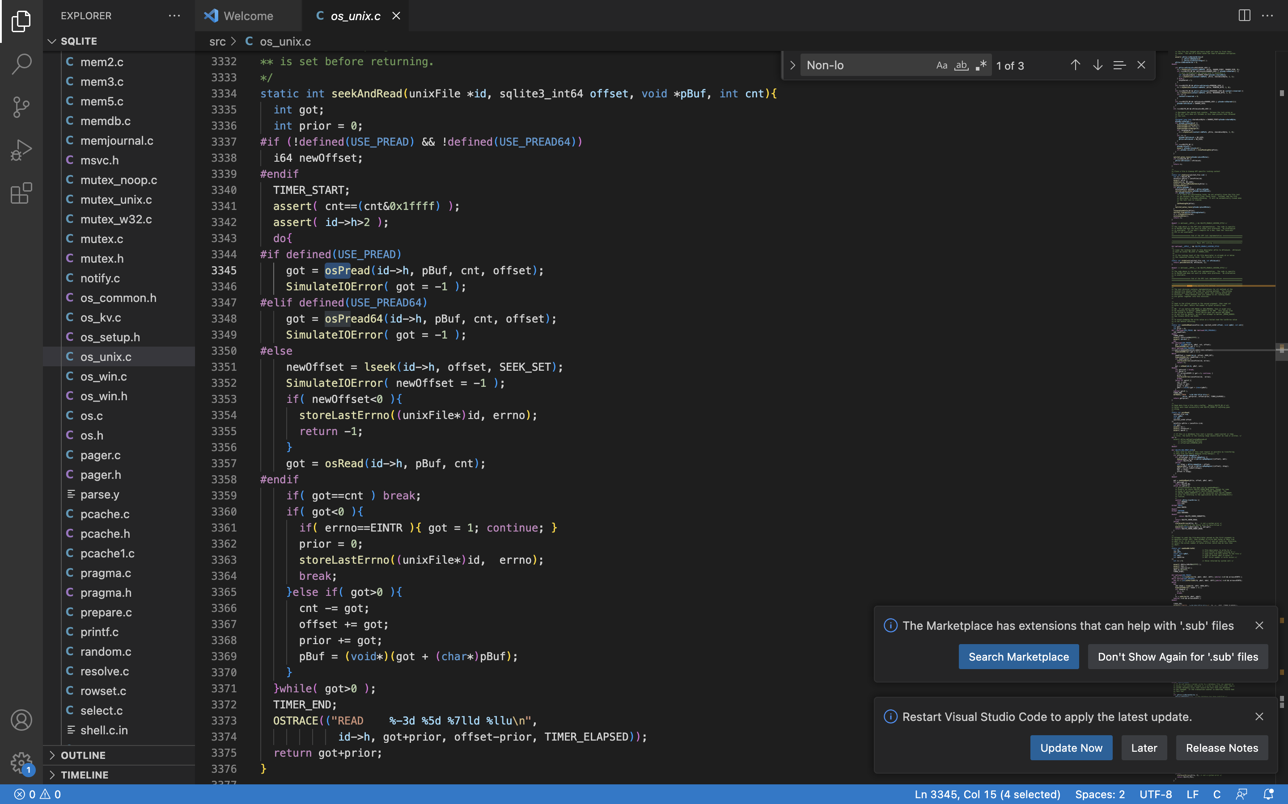

Unix write.

According to SQLite documentation, when data is modified, SQLite writes the modified pages back to the file to persist the changes.

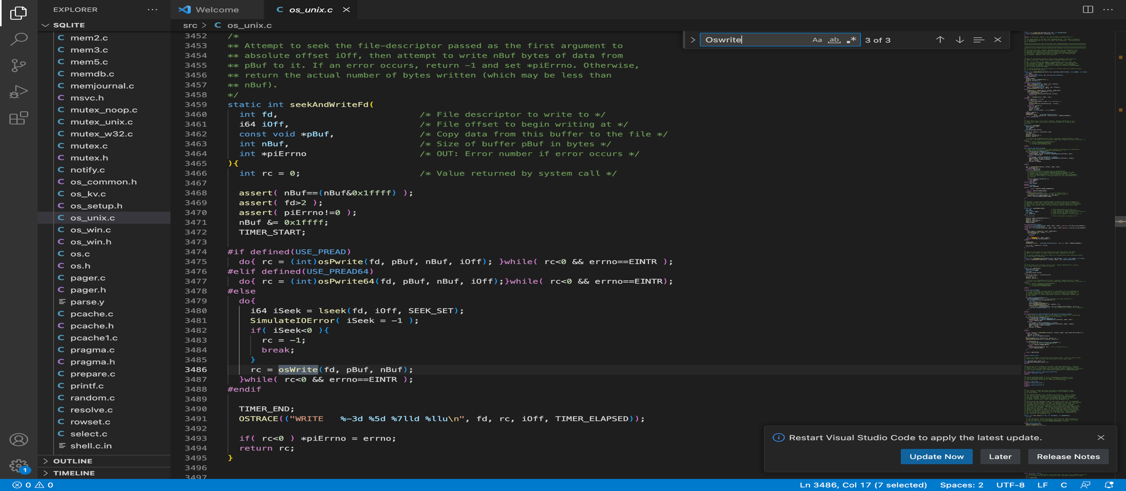

Windows read.

According to SQLite documentation , When data is read from the database, SQLite retrieves the required pages from the file into memory for processing.

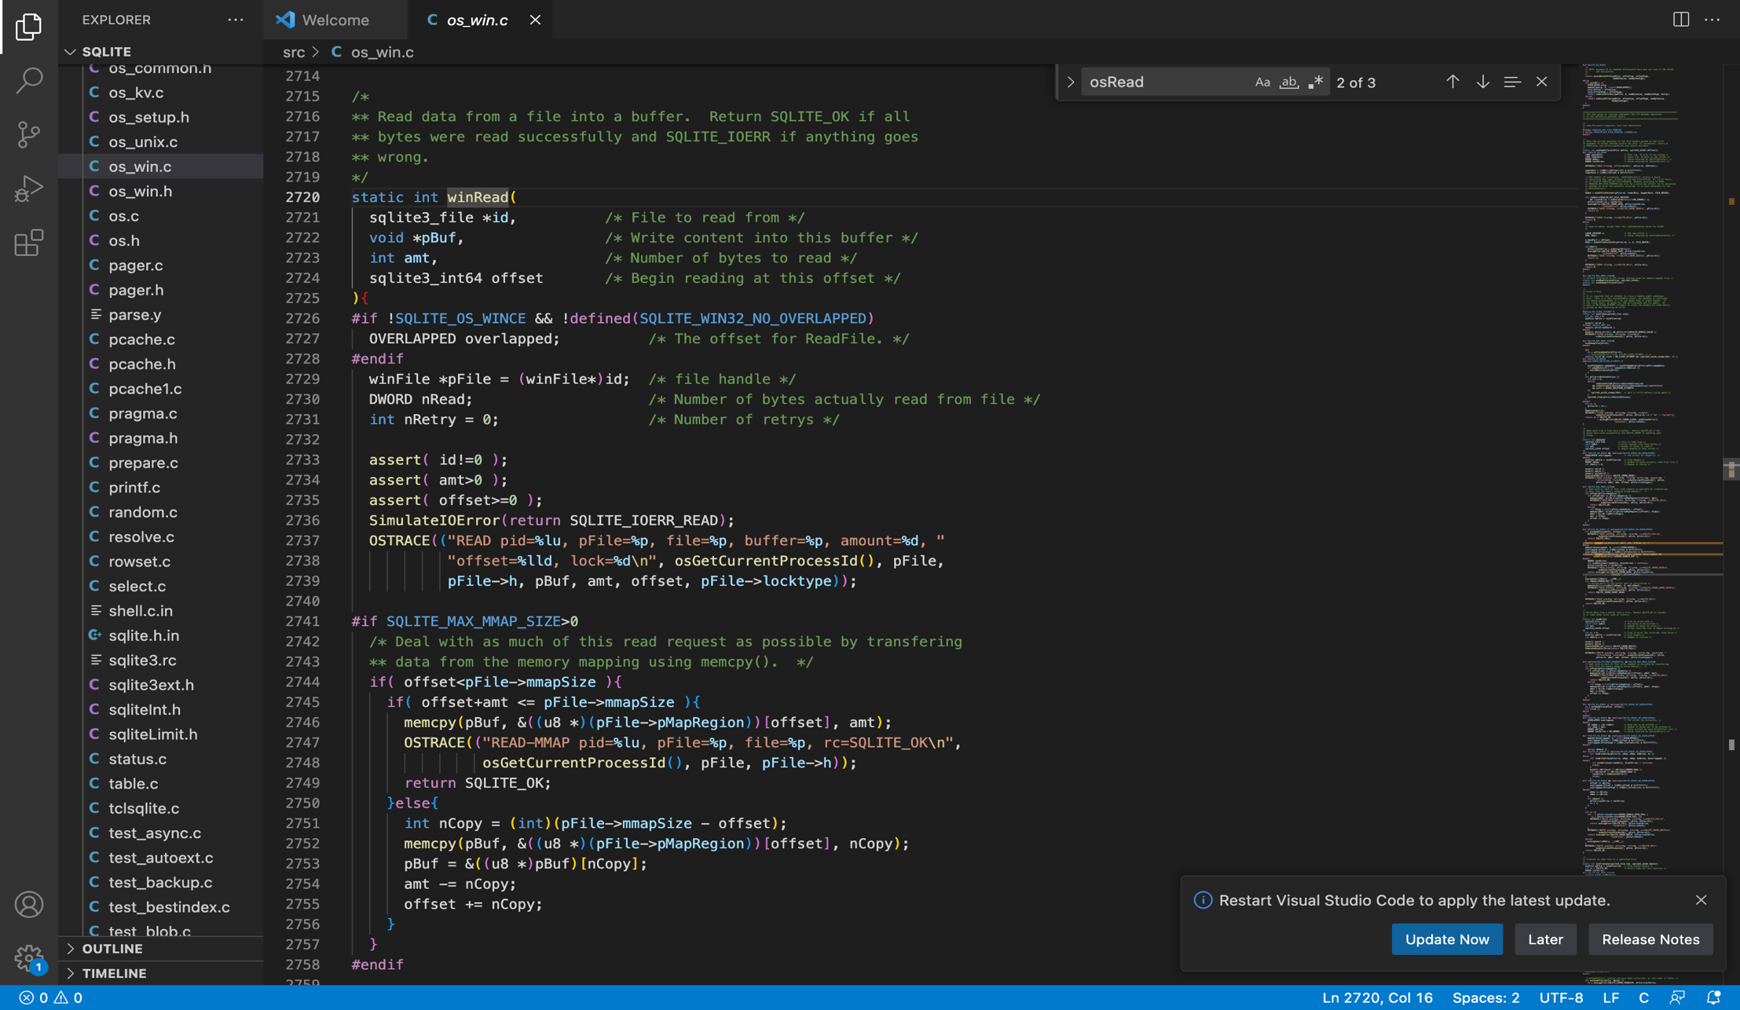

Windows write.

According to SQLite documentation, when data is modified, SQLite writes the modified pages back to the file to persist the changes.

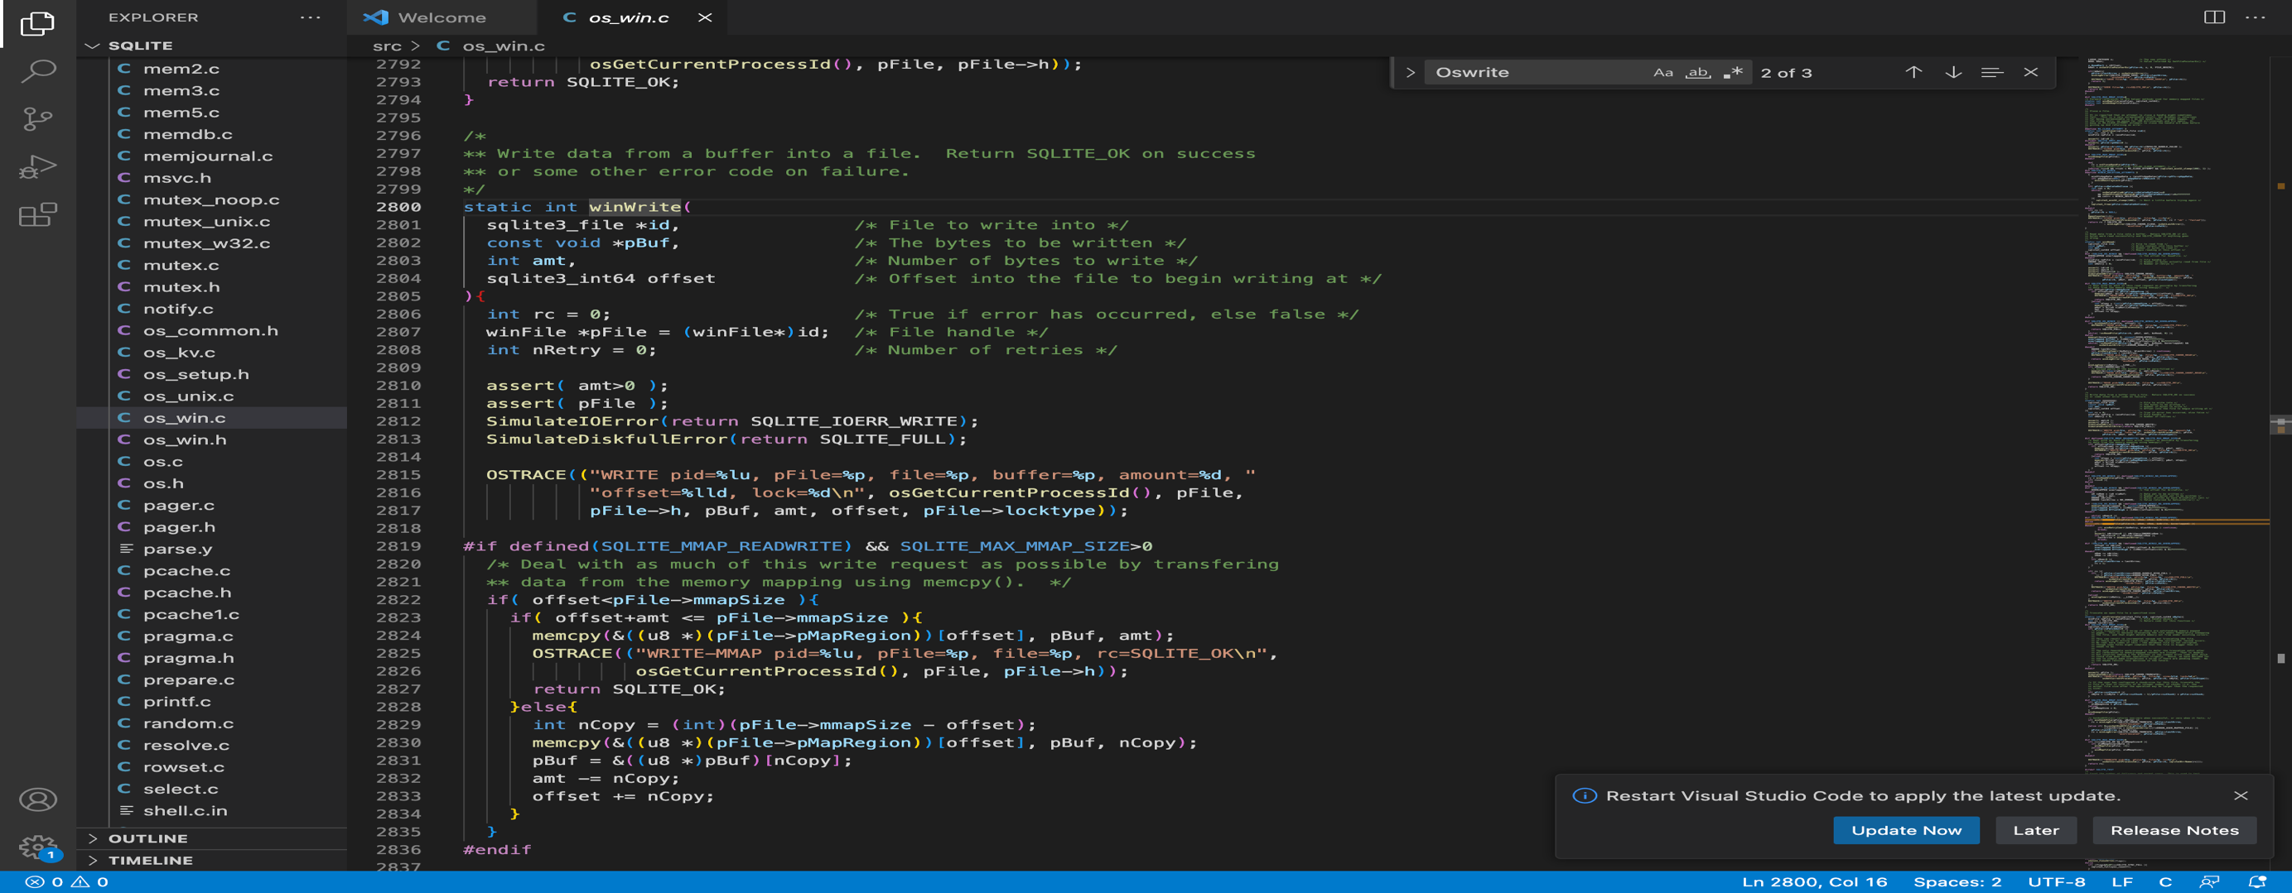

Unix close

According to SQLite documentation, Closing the database file releases associated resources, including file locks, memory buffers, and transaction states.

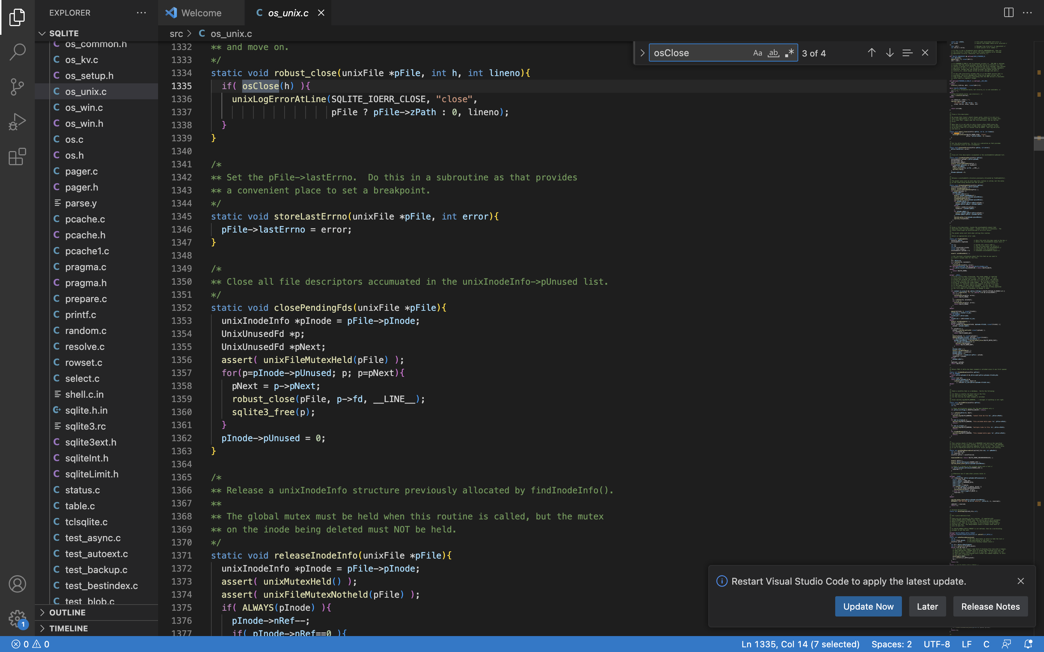

Windows close.

According to SQLite documentation, Closing the database file releases associated resources, including file locks, memory buffers, and transaction states.

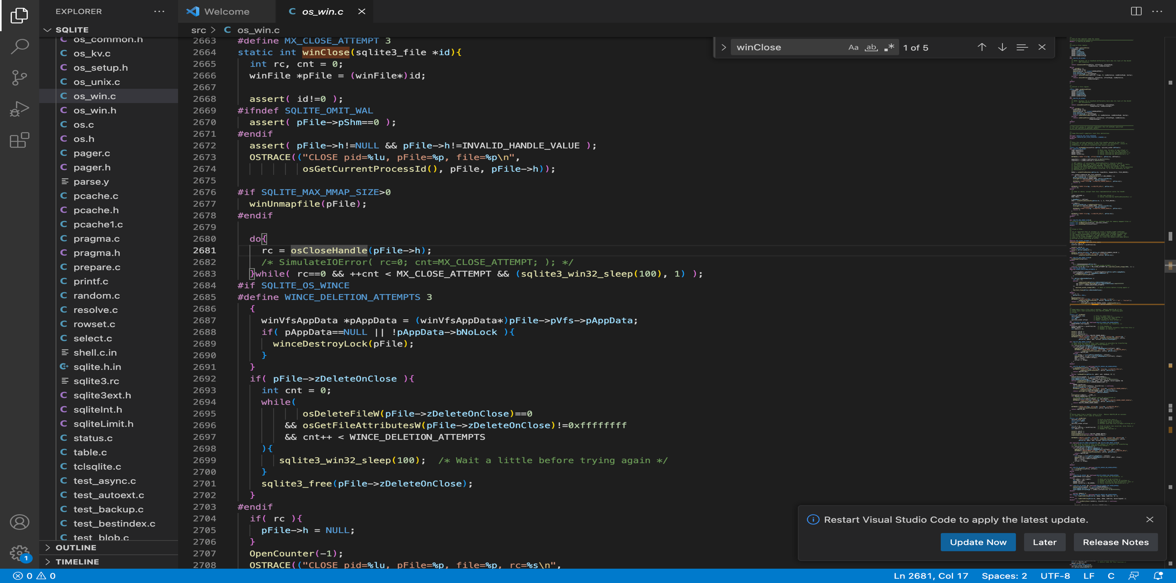

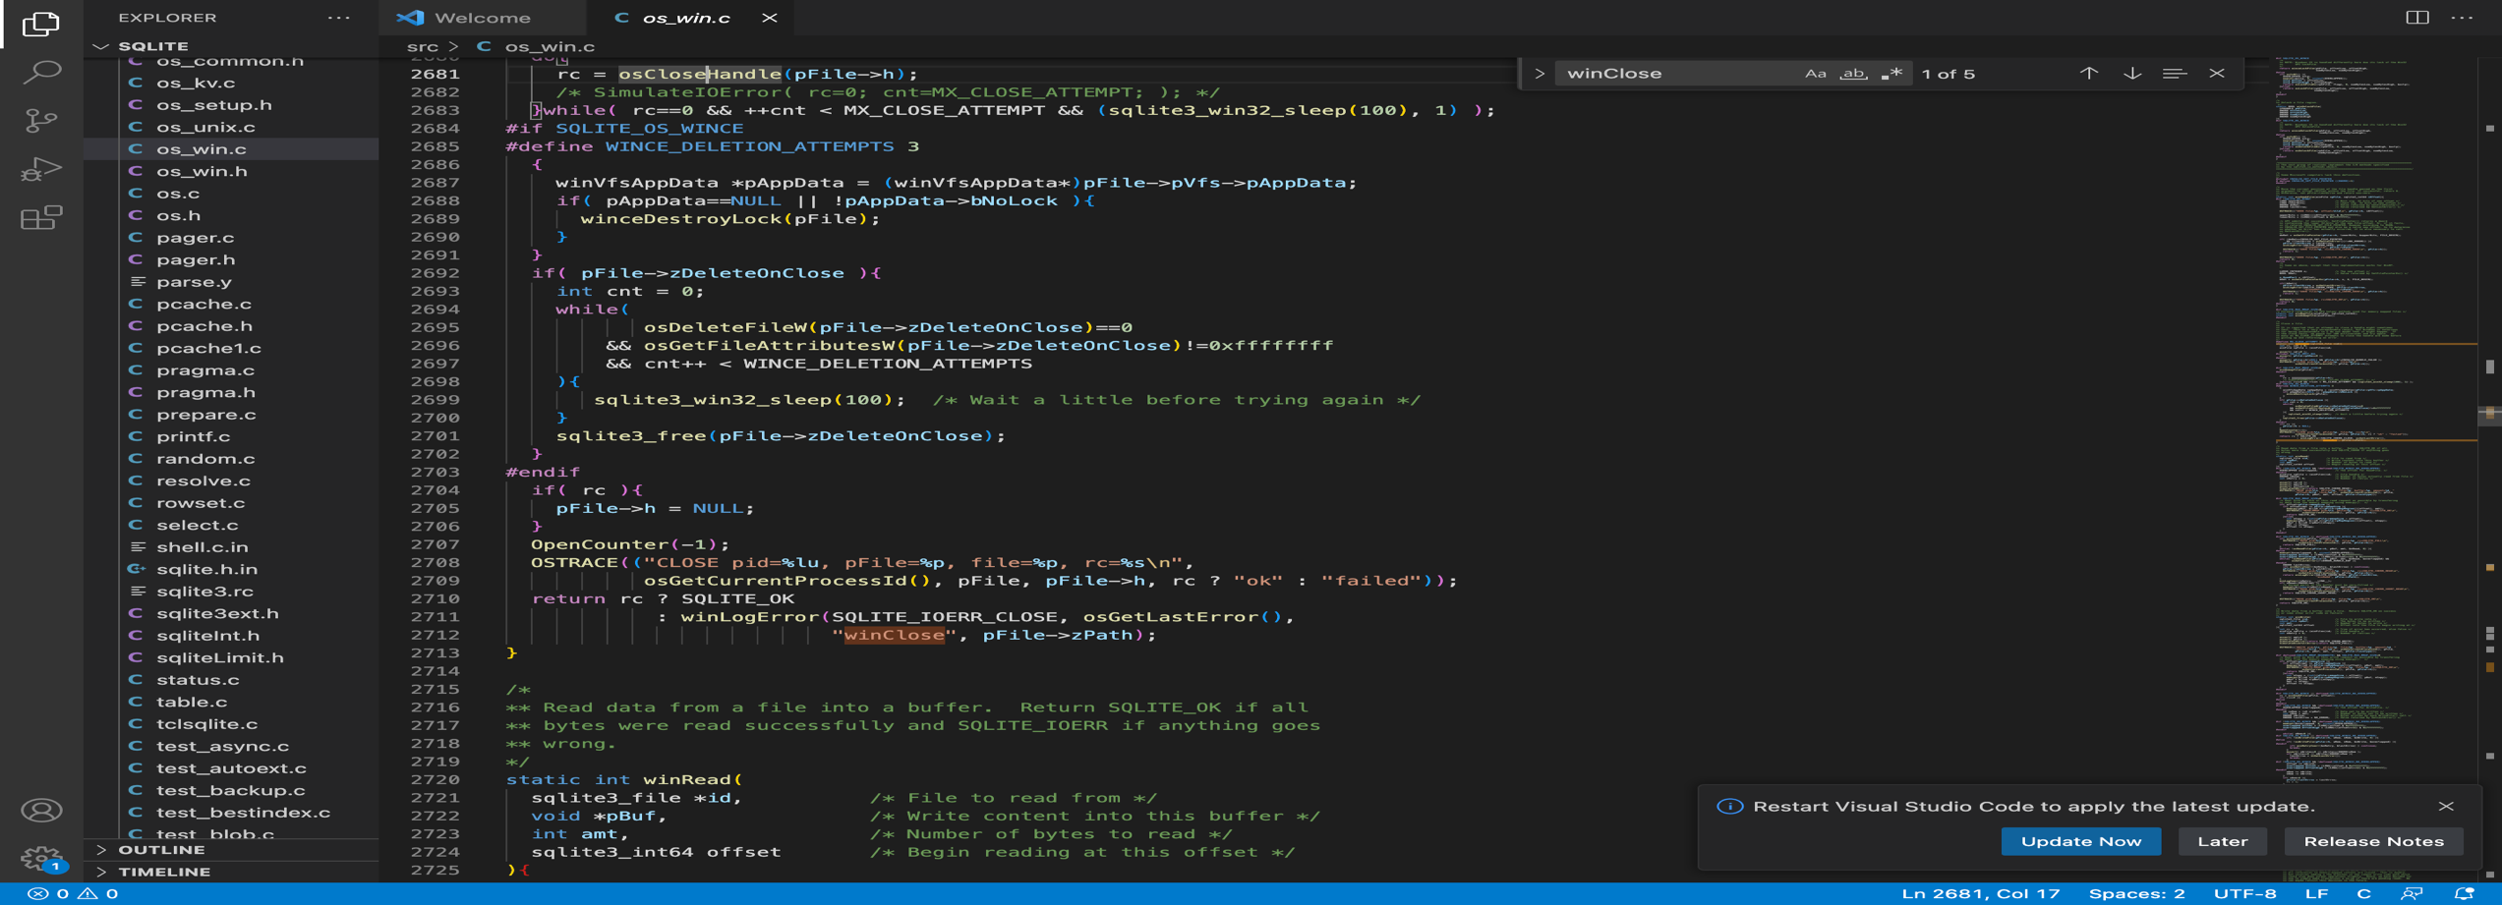

4.a

**File locking**:

According to SQLite documentation, SQLite employs file-level locking to ensure that only one process at a time can write to the database file. When a process wants to write to the database, it acquires an exclusive lock on the database file, preventing other processes from concurrently writing to it. If there are no active write locks, multiple processes can read from the database file at simultaneously.

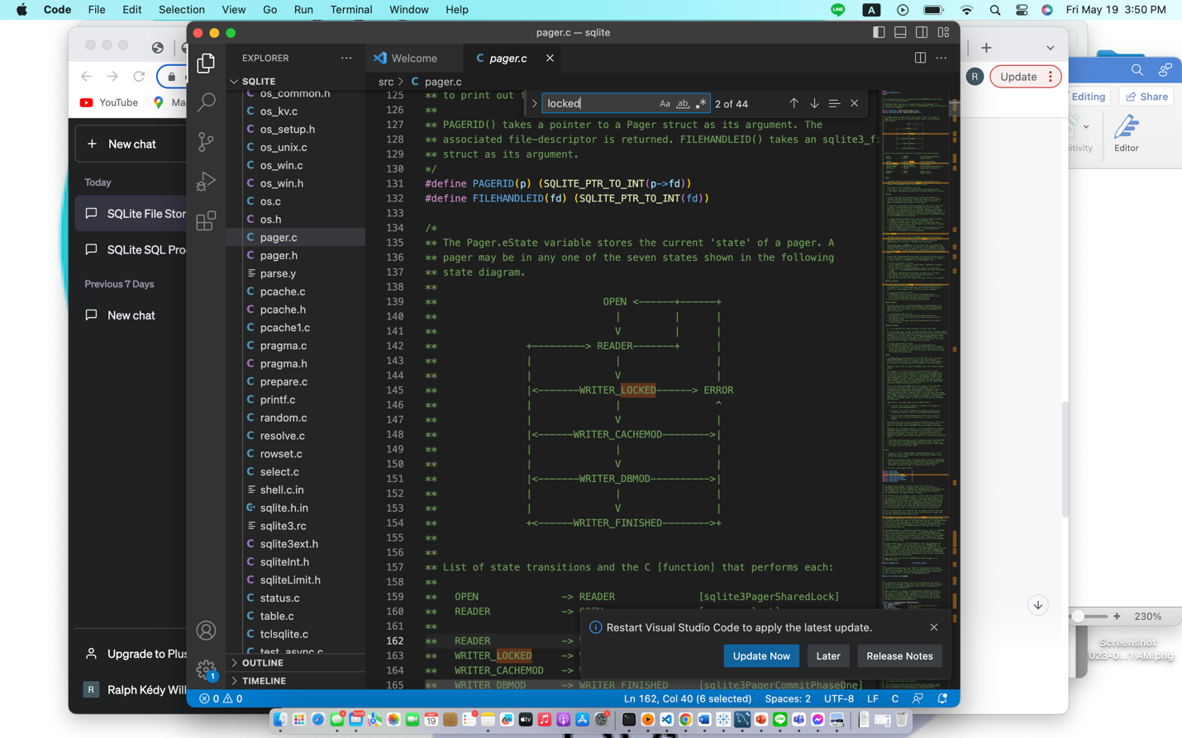

**Journal files:**According to SQLite documentation, when a process wants to modify a database file that is not in Write-Ahead Logging mode, a rollback journal is created to record the original unchanged content.

The rollback journal is an ordinary disk file with the same name and a "-journal" suffix that is in the same directory as the database file. The rollback journal also records the initial size of the database to truncate it back to the original size during a rollback if the database file grows.

If SQLite is working with multiple databases using the ATTACH command, each database has its own rollback journal. There is a separate aggregate journal called the super-journal, which contains the names of individual database rollback journals for each attached database.

Individual database rollback journals also reference the super-journal.

If no attached databases participate in the transaction, no super-journal is created, and the normal rollback journal has an empty string for the super-journal name.

A rollback journal is considered "hot" if it needs to be rolled back to preserve the integrity of its associated database.

Hot journals are created when a process is halted in the middle of a database update due to a crash or power failure.

A journal is hot if it exists, has a non-zero header, and its corresponding database file does not have a RESERVED lock, or if it is referred by a super-journal and the super-journal exists and there is no RESERVED lock on the corresponding database file.

4.**b when is the change done by an operation visible to other operations.**

**(Which operations):**

i.According to SQLite documentation, the visibility of changes depends on the isolation level and whether the transaction has been committed or not. Isolation levels such as Read Uncommitted allow immediate visibility of changes, while Read Committed, Repeatable Read, and Serializable enforce different levels of data consistency by controlling the visibility of changes to other operations.

ii. non-deterministic behavior in SQLite refers to situations where the outcome of an operation cannot be known in advance due to concurrent access or race conditions. According to the SQLite documentation, here are some scenarios where non-deterministic behavior can occur:

Uncontrolled Concurrent Updates:

Scenario: Two transactions, Transaction A and Transaction B, simultaneously update the same row in a table.Non-deterministic Outcome: The final value of the row depends on the timing and order of the updates. Depending on the execution order and concurrency, either Transaction A's or Transaction B's update may take precedence, leading to a non-deterministic result.

Unspecified Execution Order:

Scenario: Multiple transactions perform operations on the same table without explicit synchronization.Non-deterministic Outcome: The execution order of the transactions is not specified, which can lead to varying results. The interleaving of read and write operations from different transactions can cause unpredictable outcomes due to race conditions and inconsistent data access.

Concurrent Access without Proper Synchronization:

Scenario: Multiple transactions read and write to the same table without proper concurrency control mechanisms.Non-deterministic Outcome: Without proper synchronization, concurrent access to shared data can result in race conditions, leading to non-deterministic behavior. The outcome depends on the timing and order of the operations, making it difficult to predict the final state of the data.**2-B. Code Base Exploration**

* **Description of the component you choose (its functionality and role in SQLite)**

According to SQLite documentation, A B-tree is a self-balancing search tree data structure that is extensively used in database systems such as SQLite. It is crucial in SQLite for efficient data storage and retrieval. Here is a description of B-tree functionality and role in SQLite:

**B-tree Functionality:**

Ordered Data Storage: B-trees store data in a sorted order based on a specified key, generally the primary key or index key. This enables for more efficiently searching, inserting, and deleting operations.

Balanced Structure: B-trees maintain a balanced structure by ensuring that all leaf nodes are at the same depth. This balance enables more efficient data access through minimizing the number of comparisons required during search operations.

Split and Merge Operations: B-trees dynamically adjust their structure by performing split and merge operations when nodes become full or underutilized. These actions assist keep the tree balanced and optimized for efficient access.

**The Role of B-trees in SQLite**:

Table Storage: Each table in SQLite is represented by a B-tree structure called the "table b-tree." The table b-tree stores the actual table data, which is structured by primary key or row ID. The B-tree structure enables efficient row storage and retrieval based on the primary key values.

Indexing: Indexing is supported by SQLite to improve query performance. SQLite maintains a separate B-tree structure for each index defined on a table, known as the "index b-tree." The index b-tree contains the indexed data, making it possible to perform efficient lookups based on the indexed columns. Index b-trees' B-tree structure facilitates quick search operations and d supports range queries.

Sequential Access: SQLite’s B-trees are optimized for sequential access patterns, making them ideally suited for retrieving data in sorted order. Because the B-tree structure assures that consecutive data components are stored close to each other, sequential access is efficient, reducing disk seeks while improving read performance.

Disk I/O Reduction: SQLite's B-trees are intended to reduce the number of disk I/O operations. Because of the balanced structure of B-trees, accessing data requires just a small number of disk blocks to be read, resulting in faster data retrieval. Furthermore, B-trees minimize the need for full-table scans by enabling efficient index-based lookups.

Overall, B-trees are important in SQLite because they provide a balanced and efficient data structure for storing, retrieval, and indexing operations. They enable quick access to table data and effective indexing, ultimately contributing to SQLite databases' overall performance and scalability.

Related source code files in “sqlite/src/btree.c

SQLite's B-tree implementation can be found in the "btree.c" source file.

**Detail explanation of how it works (code explanation, description in documentation)**

a B-tree is a balanced tree structure used in SQLite to efficiently store and manage data in the database file. It supports insertion, deletion, and search operations while maintaining balance and minimizing disk I/O. The SQLite documentation and the source code itself provide in-depth explanations and code examples for a detailed understanding of the B-tree implementation.

Detailed explanations of the algorithms and data structures used in the B-tree implementation can be found in the SQLite documentation, specifically in the comments and documentation provided within the source code.

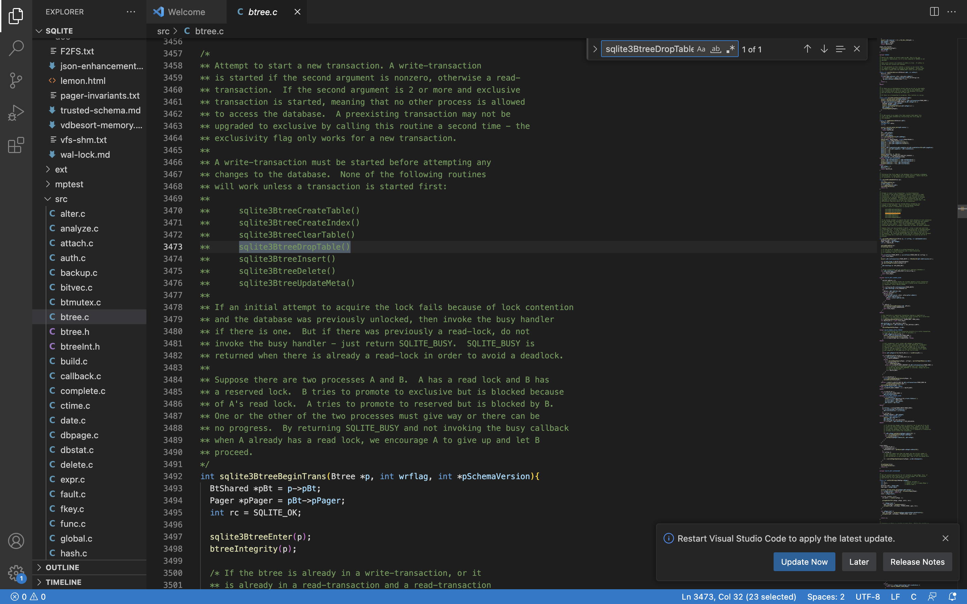

This function is about create table in the database.

